Template and instructions for submitted paper
Author*¹, Author2 and Author3

^{1, 2} Authors’ Department, Institute, Organisation, Country
(E-mail: firstauthorsname@aaaa.bbb, secondauthorsname@aaaa.bbb)
³ Author’s Department, Institute, Organisation, Country
(E-mail: thirdauthorsname@aaaa.bbb)

ABSTRACT – This is the template and instructions for submitted paper. Authors are advised to read carefully the paper guidelines, and follow them.
Keywords: One; two; three
- INTRODUCTION
The paper should be 4-6 pages in length, and fully written in English, including figures, tables and references.
The paper should explain the aim and scope of your study, the materials and methods used, the results obtained and the main conclusions reached.
- FORMAT
The structure of the extended abstract should be:
- Abstract (65 – 100 words)
- Introduction (140 – 180 words)
- Methodology
- Results and Discussion
- Conclusions (70 – 100 words)
- Acknowledgement (optional)
- References (10-20 references)
2.1 Tables, figures and equations
Examples for tables and figures are, respectively Table 1 and Figure 1.
Table 1: Table caption
Properties | Data
xxxx | 1234
xxxx | 1234

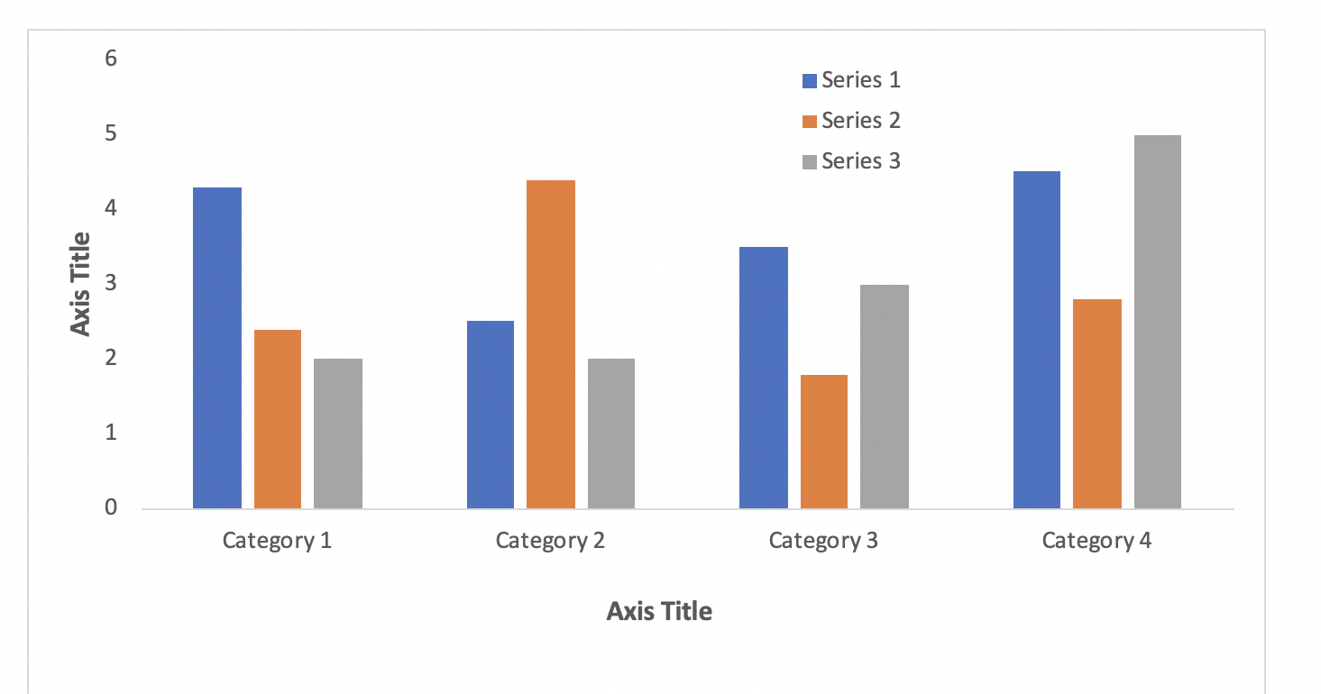

Figure 1: Figure title
Equations should be labeled as in Equation (1), with a number towards the right margin, if there is more than one equation.
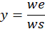 (1)

SUBMISSION
You can fill in this template and then convert to Pdf format.
Your paper must be submitted using the WSHS website submission page, accessing “Submit paper”:
https://ent.univ-constantine3.dz/wshs2025

REFERENCES
References should be listed as cited in the text, using reference numbers and presented in the following format:
[1] J.D. Jacobson, M.D. Kennedy, G. Amy and J.C. Schippers, Phosphate limitation in reverse osmosis: An option to control biofouling?, Alg. J. Eng. Res., 1 (2016) 198–206. (Articles in journals)
[2] M. Mickley, In: M. Wilf, Guidebook to Membrane Desalination Technology, University Constantine 3 Publications, Constantine 2007, pp. 375–389.(Chapters in books)
[3] R. Sheikholeslami, Fouling of Membrane and Thermal Units. A Unified Approach to its Principles, Assessment, Control, and Mitigation, University Constantine 3Publications, Constantine, 2007. (Books)

